**OPTIMIZATION OF NUMBER OF EMPLOYEES FOR A GARMENT MANUFACTURING FIRM USING INTEGER LINEAR PROGRAMMING MODEL ILP**

**Objective**

This project aims to allocate number of full-time employees and floaters (employees who are trained in all the activities and are assigned duties to a department based on daily needs) in a garment manufacturing firm which is into the business of end-to-end garment manufacturing right from the process of fabric inspection to the final packaging. The various stages of a garment manufacturing are shown in this block diagram.

* How many employees to deploy in each department so that all the constraints are satisfied
* Minimize the daily cost to the company in terms of the daily wages

**Introduction:**

**Company:** ABCGarments is a hypothetical firm which has been created for the reason of practicing a data optimization problem.

**Problem:** Depending upon the complexities and expertise in different departments, the per hour wage for the same varies. Each department runs for 8 hours a day, and the per hour cost for the same is tabulated below:

|  |  |
| --- | --- |
| Department | Per hour Wage (in USD) |
| Fabric Inspection | 18 |
| Trims/Purchasing | 16 |
| Spreading | 18 |
| Cutting | 20 |
| Sewing | 25 |
| Final Quality Inspection | 17 |
| Packaging | 16 |

Moreover, each department has its own constraints on minimum and maximum no. of employees per day which are listed below.

* Minimum total number of full-time employees and floaters: 285
* Maximum total number of full-time employees and floaters: 300
* Maximum number of floaters: 10% of full-time employees
* Minimum number of employees in Fabric Inspection Department: 25
* Minimum number of employees in Trims/Purchase Department: 15
* Minimum number of employees in Spreading Department: 35
* Minimum number of employees in Cutting Department: 45
* Minimum number of employees in Sewing Department: 70
* Minimum number of employees in Final Inspection Department: 20
* Minimum number of employees in Packaging Department: 25
* Minimum number of floaters in Fabric Inspection Department: 1
* Maximum number of floaters in Fabric Inspection Department: 3
* Number of floaters in Trims/Purchase Department: 1
* Minimum number of floaters in Spreading Department: 1
* Maximum number of floaters in Spreading Department: 3
* Minimum number of floaters in Cutting Department: 1
* Maximum number of floaters in Cutting Department: 4
* Number of floaters in Sewing Department: at least 8
* Minimum number of floaters in Fabric Inspection Department: 1
* Maximum number of floaters in Fabric Inspection Department: 3
* Minimum number of floaters in Packaging Department: 1
* Maximum number of floaters in Packaging Department: 3

**Proposed Solution:**

To determine the no. of fulltime employees and floaters required per department, an integer linear programming model has been developed which satisfies all the constraints and minimizes the total daily wage to the company. This will ultimately add to the net profit of ABC garments.

Decision Variables are:

* E1 = Number of employees in Fabric Inspection Department
* E2 = Number of employees in Trims/Purchase Department
* E3 = Number of employees in Spreading Department
* E4 = Number of employees in Cutting Department
* E5 = Number of employees in Sewing Department
* E6 = Number of employees in Final Inspection Department
* E7 = Number of employees in Packaging Department
* F1 = Number of floaters in Fabric Inspection Department
* F2 = Number of floaters in Trims/Purchase Department
* F3 = Number of floaters in Spreading Department
* F4 = Number of floaters in Cutting Department
* F5 = Number of floaters in Sewing Department
* F6 = Number of floaters in Fabric Inspection Department
* F7 = Number of floaters in Packaging Department

***The objective function is shown as: Sum Product (Number of Employees * Daily Wages)***

The mathematical equations of the constraints are:

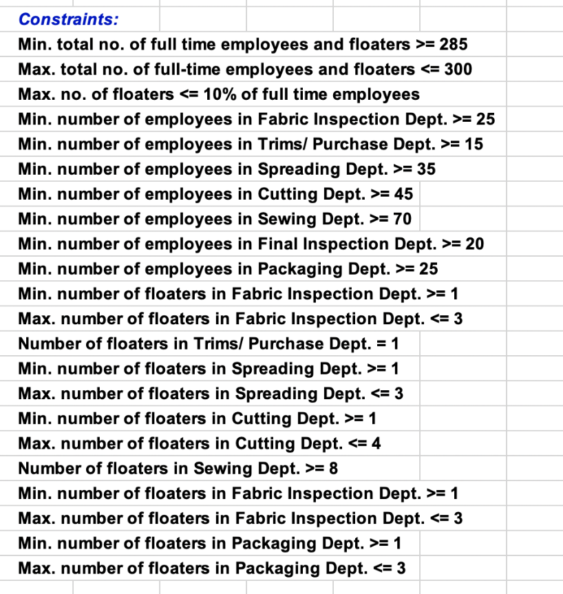

The objective function (Minimize) and Decision variables have been feed into the solver parameters along with the long string of constraints and opted for an Integer Linear programming model since the decision variables i.e., the no. of employees are supposed to be whole numbers i.e., integers. The tool then automatically invoked using branch-and-bound method in the calculations.

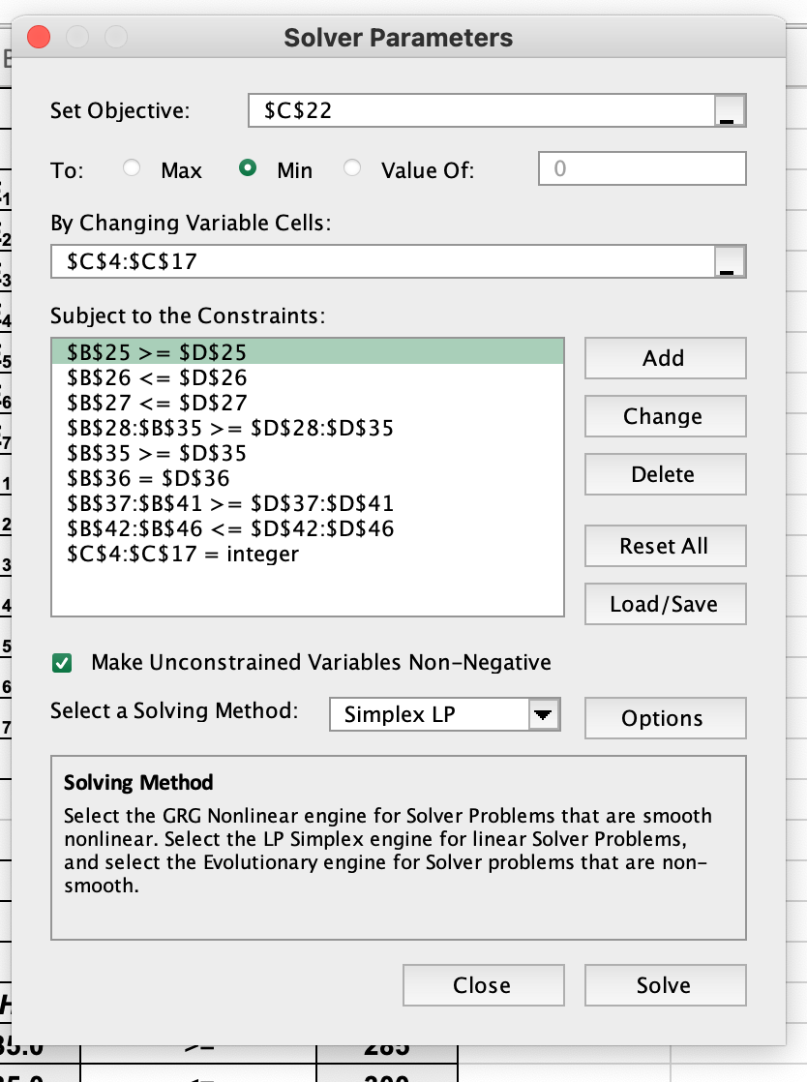

**Solution Results and Analysis:** From the solver, it is found that the minimum daily wage cost has to be **$44,456** for ABC Garments, the optimum number of employees in each department with constraints met are shown below, these are the values of the decision variables.

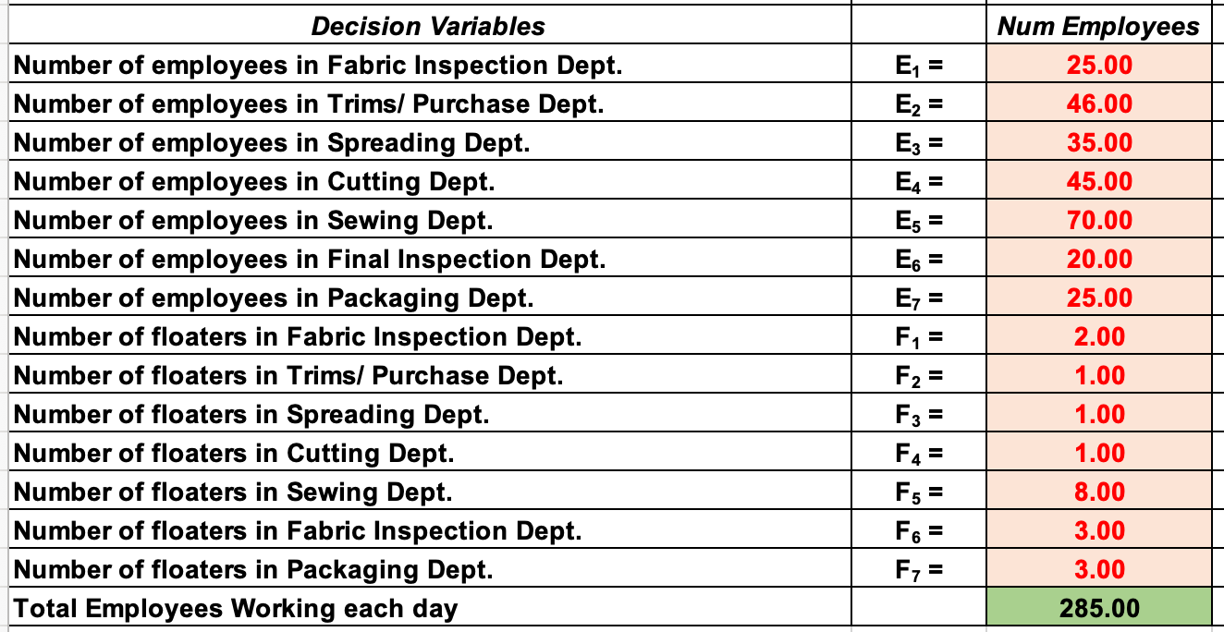

It can be said that ABC Garments need **285** **employees** to be working daily. This includes full-time employees and floaters.

**Sensitivity Analysis:**

Since the most important department is the sewing, ABC Garments may want to study the impact of the number of employees on the objective function, also on the number of employees in other departments (E1 to E7). The findings for each parameter are discussed below:

1. A graph with a line going up

   Description automatically generatedImpact of Number of employees in Sewing Dept. on the objective function:

The results of sensitivity analysis show that the minimum daily wage is sensitive to variation in the number of employees in the sewing department, as number of employees increases the total daily wage also increases.

1. A graph with a line and numbers

   Description automatically generatedImpact of Number of employees in Sewing Dept. on the Number of employees in Fabric Inspection Dept:

The results of sensitivity analysis show that Number of employees in Fabric Inspection Dept. is **insensitive** to variation in the number of employees in the sewing department. It remains constant at 25

1. Impact of Number of employees in Sewing Dept. on the Number of employees in Fabric Inspection Dept:

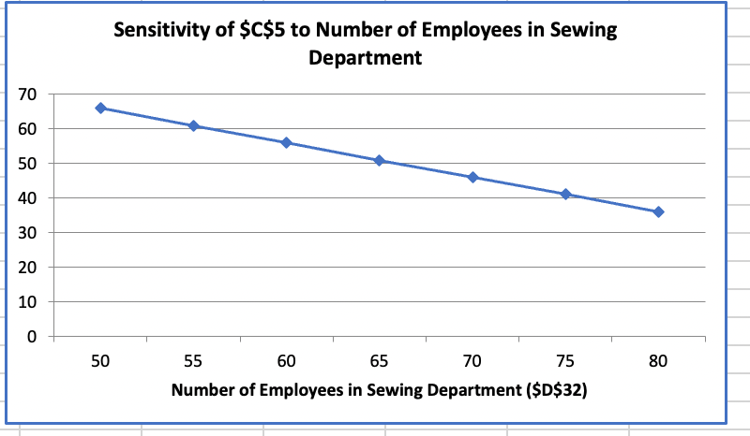

The results of sensitivity analysis show that Number of employees in Fabric Inspection Dept. is **sensitive** to variation in the number of employees in the sewing department. As number of employees of sewing department increases, the number of employees in fabric inspection decreases.

1. A graph with a blue line

   Description automatically generated Number of employees in Sewing Dept. on the Number of employees in Trims/ Purchase Dept.

The results of sensitivity analysis show that Number of employees in Trims/Purchase Dept. is **insensitive** to variation in the number of employees in the sewing department. It remains constant at 35.

1. Impact of Number of employees in Sewing Dept. on Number of employees in Spreading Dept.

The results of sensitivity analysis show that Number of employees in Spreading Dept. is **insensitive** to variation in the number of employees in the sewing department. It remains constant at 45

1. A graph with a blue line

   Description automatically generatedImpact of Number of employees in Sewing Dept. on the Number of employees in Cutting Dept.

The results of sensitivity analysis show that Number of employees in Cutting Dept. is **sensitive** to variation in the number of employees in the sewing department. As number of employees of sewing department increases, the number of employees in cutting department also increases.

1. Impact of Number of employees in Sewing Dept. on Number of employees in Final Inspection Dept:

The results of sensitivity analysis show that Number of employees in Final Inspection Dept. is **insensitive** to variation in the number of employees in the sewing department. It remains constant at 20

1. Impact of Number of employees in Sewing Dept. on Number of employees in Packaging Dept.:

The results of sensitivity analysis show that Number of employees in Packaging Dept. is **insensitive** to variation in the number of employees in the sewing department. It remains constant at 25

**Conclusion:**

The results of the ILP model for ABC Garments can be concluded to the following points.

1. Minimum Daily Wage cost: $44,456
2. Total employees needed daily to carry all operations: 285